**ANDROID DOCS – DAY1**

**Activity –** The screen or interface that users see. In the base application there is MainActivity  
 which means the main screen where the users see.

**@Composable –** Element that you can see on the screen. It contains the other composable  
 that are visible or it can bee see itself.

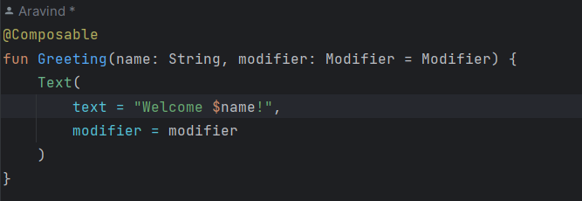  
what this means is the Greeting is a method and the function should execute a text composable. The text should say welcome $name

Modifier:- It tells the how the appearance of the composable to look like. Eg: fillMaxSize, color etc.

$name :- is basically saying whatever this name up here is executed. That name is passing from some other place where the method is called.

Eg:  
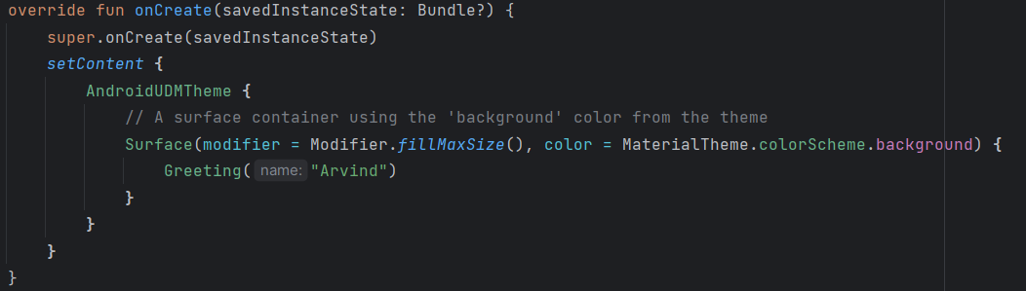

**Preview** – It allows developers to see a virtual representation of parts of the application  
 without running it.